**Advantis Dental Surgeries System – Domain Model UML Class Diagram and problem Statement.**

**Summary:**

* **System Overview**
* **Entities (Domain Objects)**
* **Functional Requirements**
* **Non-Functional Requirements**
* **Domain Model UML Class Diagram (with explanation)**
* **Entity Relationships Summary**

## ****1. System Overview****

Advantis Dental Surgeries (ADS) manages a network of dental clinics across multiple cities. The company needs a **web-based information system** to manage its day-to-day operations including registering dentists and patients, scheduling appointments, managing surgery locations, and handling billing activities.

The system serves three main users:

* **Office Manager:** Registers dentists and patients, books and manages appointments, and handles billing.
* **Dentist:** Views scheduled appointments and patient details.
* **Patient:** Requests, cancels, or reschedules appointments and views their assigned dentist and surgery details.

The system enforces key business rules:

1. A dentist cannot have more than **five appointments per week**.
2. A patient with **outstanding unpaid bills** cannot book new appointments.

This software will streamline administrative work, ensure accurate scheduling, and improve communication between ADS staff, dentists, and patients.

## ****2. Entities (Domain Objects)****

| **SN** | **Entity** | **Description** |
| --- | --- | --- |
| **1** | **OfficeManager** | Represents the administrative user who manages dentists, patients, and appointments. |
| **2** | **Dentist** | Represents a dental professional in the ADS network, with unique contact and specialization details. |
| **3** | **Patient** | Represents a registered client seeking dental services, with contact info and demographics. |
| **4** | **Appointment** | Represents a booking between a patient and a dentist at a specific surgery location, with date and time. |
| **5** | **Surgery** | Represents a physical dental surgery location (clinic) with address and phone details. |
| **6** | **Bill** | Represents a financial record linked to an appointment, indicating the amount and payment status. |

## 3. Functional Requirements

| **ID** | **Requirement Description** |
| --- | --- |
| **FR1** | The system shall allow the Office Manager to register new dentists. |
| **FR2** | The system shall allow the Office Manager to register new patients. |
| **FR3** | The system shall allow patients to request appointments online or via phone. |
| **FR4** | The Office Manager shall be able to schedule, update, or cancel appointments. |
| **FR5** | The system shall automatically send appointment confirmation emails to patients. |
| **FR6** | Dentists shall be able to log in and view all their appointments. |
| **FR7** | Patients shall be able to log in to view, cancel, or reschedule appointments. |
| **FR8** | The system shall display details of surgery locations for each appointment. |
| **FR9** | The system shall generate and store a bill for every appointment. |
| **FR10** | The system shall prevent a dentist from being assigned more than five appointments per week. |
| **FR11** | The system shall prevent a patient with unpaid bills from booking new appointments. |
| **FR12** | The system shall allow the Office Manager to update bill payment statuses. |

## 4. Non-Functional Requirements

| **Category** | **Requirement Description** |
| --- | --- |
| **Usability** | The system shall provide a user-friendly web interface accessible on desktops and tablets. |
| **Performance** | The system shall respond to user requests (login, booking, viewing appointments) within 2 seconds. |
| **Security** | Only authorized users (manager, dentist, patient) shall access the system using login credentials. |
| **Scalability** | The system shall support multiple dental clinics and up to 10,000 users concurrently. |
| **Reliability** | The system shall maintain data integrity during concurrent operations and recover from crashes. |
| **Maintainability** | The system shall be modular and follow a layered architecture to simplify updates and debugging. |
| **Availability** | The system shall maintain 99% uptime during working hours. |
| **Portability** | The system shall be deployable on both cloud and on-premise environments. |
| **Auditability** | The system shall log all major actions (registrations, bookings, billing updates). |

## 5. Domain Model UML Class Diagram ****Diagram Description****

* **OfficeManager** registers **Dentists** and **Patients** (1 → *).
* **Patient** books **Appointments** (1 → *).
* **Dentist** attends **Appointments** (1 → *).
* **Surgery** hosts **Appointments** (1 → *).
* Each **Appointment** generates one **Bill** (1 → 1).
* Each **Patient** owes one or more **Bills** (1 → *).
* Constraints:
  + A dentist can have a maximum of 5 appointments per week.
  + A patient with unpaid bills cannot create a new appointment.

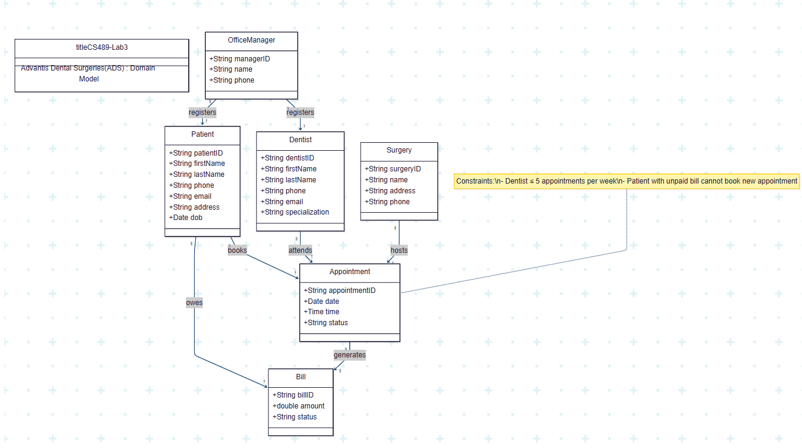

**6. Entity Relationship Summary**

| **From Entity** | **To Entity** | **Relationship Name** | **Multiplicity** | **Description** |
| --- | --- | --- | --- | --- |
| Office Manager | Dentist | registers | 1 → * | One manager can register multiple dentists. |
| Office Manager | Patient | registers | 1 → * | One manager can register multiple patients. |
| Patient | Appointment | books | 1 → * | Each patient can book multiple appointments. |
| Dentist | Appointment | attends | 1 → * | Each dentist can attend multiple appointments (≤5 per week). |
| Surgery | Appointment | hosts | 1 → * | Each surgery can host multiple appointments. |
| Appointment | Bill | generates | 1 → 1 | Each appointment generates exactly one bill. |
| Patient | Bill | owes | 1 → * | Each patient can have multiple bills. |

**7. Use Case**

Actor OfficeManager as OM

Actor Dentist as D

Actor Patient as P

**Office Manager Actions**

(Register Dentist) as UC1

(Register Patient) as UC2

(Book Appointment) as UC3

(Cancel / Reschedule Appointment) as UC4

(Send Confirmation Email) as UC5

(Generate Bill) as UC6

(Update Bill Status) as UC7

**Dentist actions**

(View Appointments) as UC8

(View Patient Details) as UC9

**Patient actions**

(Request Appointment) as UC10

(View Appointments) as UC11

(Cancel / Change Appointment) as UC12

(View Bill Status) as UC13

**Summary of the use case**

## ****Diagram Explanation****

| **Actor** | **Role in System** | **Key Use Cases** |
| --- | --- | --- |
| **Office Manager** | Manages all core operations — dentist registration, patient onboarding, appointment scheduling, billing, and communication. | Register Dentist, Register Patient, Book Appointment, Send Confirmation Email, Generate Bill, Update Bill Status |
| **Dentist** | Views assigned appointments and patient details to prepare for consultations. | View Appointments, View Patient Details |
| **Patient** | Interacts with the system to request, view, and manage appointments and bills. | Request Appointment, View Appointments, Cancel/Change Appointment, View Bill Status |

### 8. High-Level Architecture Overview ****Microservice-Based Architecture for Advantis Dental Surgeries (ADS)****

Each major domain (from your UML) becomes an independent **bounded context** / **microservice**, communicating through REST APIs and Kafka events.  
**Microservices Breakdown**

| **Microservice** | **Responsibility** | **Main Entities** | **Event Topics** |
| --- | --- | --- | --- |
| **Patient Service** | Manage patients, profiles, and billing linkages | Patient, Bill | patient.created, bill.updated |
| **Dentist Service** | Manage dentist registration, specialization, and schedules | Dentist | dentist.created, appointment.limit.check |
| **Appointment Service** | Handle all appointment creation, updates, cancellations | Appointment | appointment.created, appointment.canceled |
| **Billing Service** | Generate, track, and update payment status for appointments | Bill | bill.generated, bill.paid |
| **Surgery Service** | Manage surgery locations and schedules | Surgery | surgery.updated |
| **Notification Service** | Send appointment confirmation and cancellation emails | (No entity, uses Kafka consumer) | Consumes: appointment.created, appointment.canceled |

**Microservice Supporting Components**

| **Component** | **Purpose** |
| --- | --- |
| **API Gateway (Spring Cloud Gateway)** | Central entry point for routing requests to backend services (authentication, rate limiting, load balancing). |
| **Kafka Broker** | Enables asynchronous, event-driven communication between services. |
| **Resilience4j / Circuit Breaker** | Ensures system stability during service failures or high latency. |
| **Eureka Discovery Server (Optional)** | Service registry for dynamic discovery and routing. |
| **Config Server (Optional)** | Centralized management of service configurations. |

**Port Assignment**

| **Service** | **Port** | **Description** |
| --- | --- | --- |
| API Gateway | **8080** | Entry point, routing & JWT filter |
| Patient Service | **8081** | Manages patient and bill linkage |
| Dentist Service | **8082** | Manages dentist data & schedule |
| Appointment Service | **8083** | Manages appointments |
| Billing Service | **8084** | Handles billing generation/payment |
| Surgery Service | **8085** | Manages surgery locations |
| Notification Service | **8086** | Sends emails via Kafka events |
| Auth Service | **8089** | JWT login/signup authentication |
| Kafka Broker | **9092** | Message broker for events |

**Scalable System Architecture Diagram**

**Without Security**

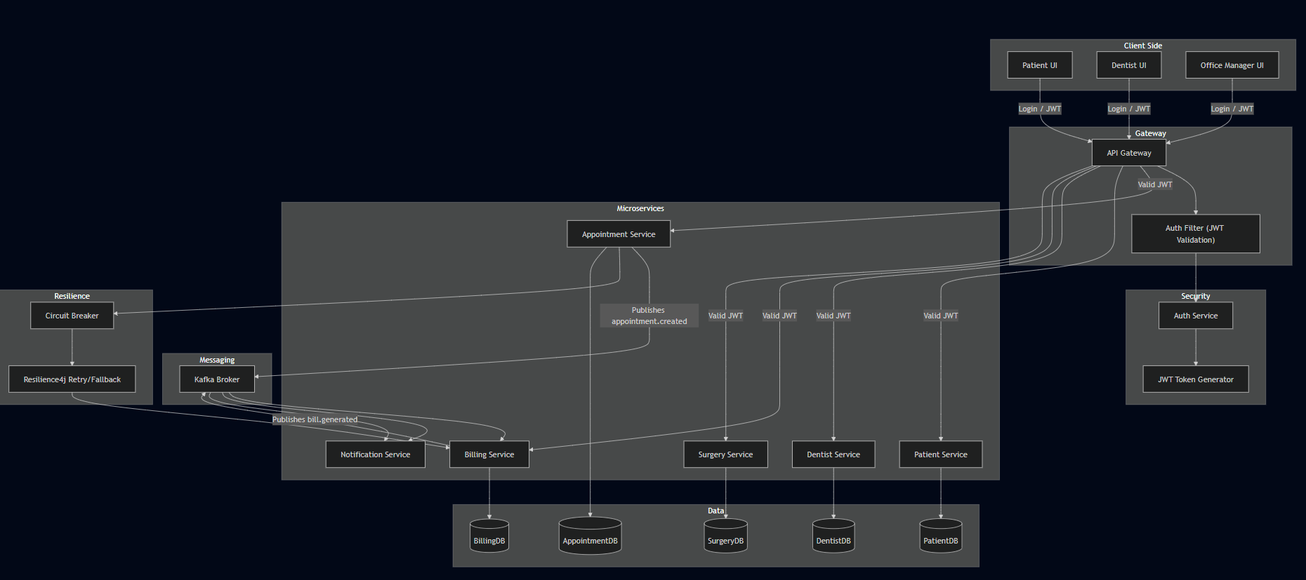

**Break down with security**

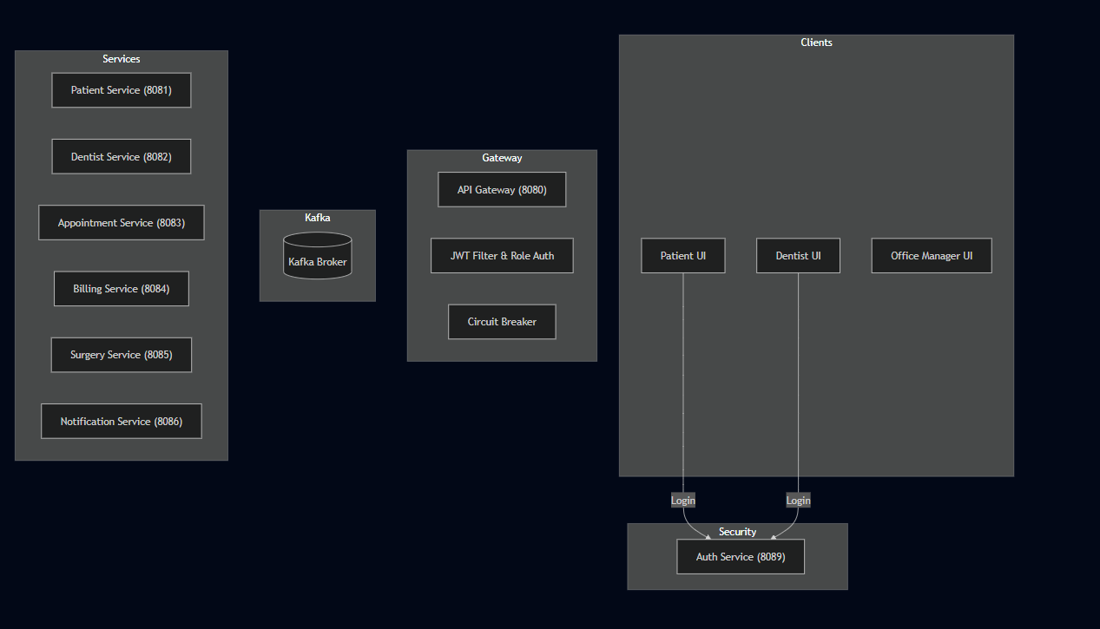

**Overall Architecture**

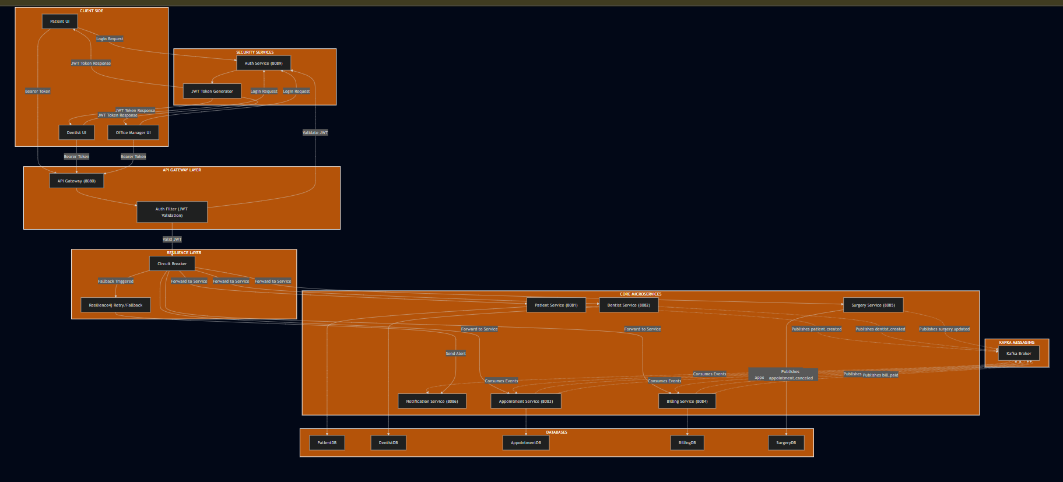

**Client side**

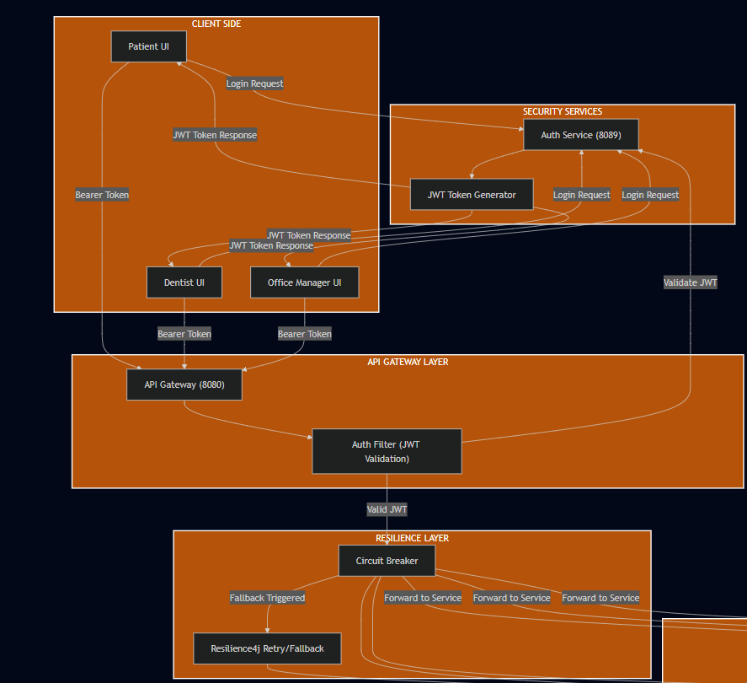

**MicroServices side**

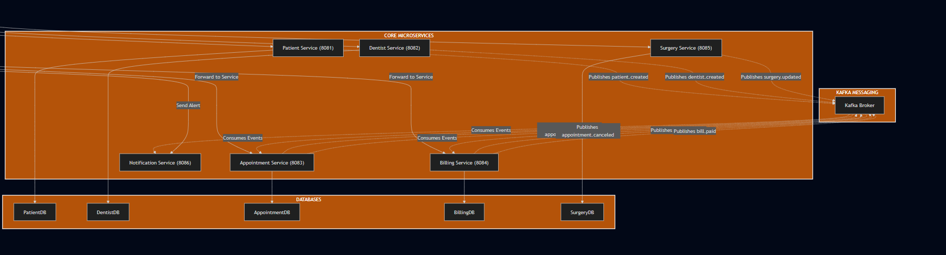

**Security control:**

**My Security Architecture  
